POLICY NAME: Tangible Capital Asset Policy

POLICY NO.: 400-4

DATE ADOPTED: August 11, 2008

DATE AMENDED/REVIEWED: April 21, 2020

1.0 PURPOSE:

The objective of this policy is it to outline the accounting and reporting requirements for tangible capital assets.

2.0 SCOPE:
This policy applies to all rural municipality departments, boards and commissions, agencies and other organizations falling within the reporting entity of the rural municipality.

3.0 DEFINITIONS:

Amortization is a rational and systematic manner of allocating the cost of an asset over its estimated useful life.

Betterments are enhancements to be the service potential of a capital asset such as: o an increase in the previously assessed physical output or service capacity; o a reduction in associated operating costs; o an extension of the estimated useful life; or o an improvement in the quality of output.

Capital Assets are non-financial assets having physical substance that:
- are held for use by the municipality in the production or supply of goods and services, for rental to others, for administrative purposes or for the development, construction, maintenance or repair of other tangible capital assets;
- have useful lives extending beyond a year and are intended to be used on a continuing basis; and
- are not intended for sale in the ordinary course of operations.

Capital-type expenses are costs for assets that meet the definition of a capital asset but are less than the thresholds. These assets are expensed in the year in which they are purchased.
Cost is the amount of consideration given up to acquire, construct, develop or better a capital asset and includes all costs directly attributable to its acquisition, construction, development or betterment, including installing the asset at the location and in the condition necessary for its intended use. The cost of a contributed capital asset is considered to be equal to its fair value at the date of contribution.

Disposal refers to the removal of a capital asset from service as a result of sale, destruction, loss or abandonment.

Estimated Useful Life is the estimate of the period over which a capital asset is expected to be used or the number of units of production that can be obtained from the asset. It is the period over which an asset will be amortized and is normally the shortest of the physical, technological, commercial or legal life.
Fair Value is the amount of the consideration that would be agreed upon in an arm's length transaction between knowledgeable, willing parties, who are under no compulsion to act.

Financial Assets are assets that are available to discharge existing liabilities or finance further operations and are not for consumption in the normal course of operations. Examples of financial assets are cash on hand, accounts receivable and inventories for resale.

Gain on Disposal is the amount by which the net proceeds realized upon as asset's disposal exceed the asset's net book value.

Hours of Production Method is an amortization method which allocated the cost of an asset based on its estimated hours of use or production.

Leased Capital Assets are non-financial assets leased by the municipality for use in the delivery of goods and services. Substantially all of the benefits and risks of ownership are transferred to the municipality without requiring the transfer of legal ownership.

Loss on Disposal is the amount by which the net book value of a capital asset exceeds the net proceeds realized upon the asset's disposal.

Net book Value is the capital asset cost less accumulated amortization and any write-downs. It represents the asset's unconsumed cost.

Non-financial Assets are assets that do not normally provide resources to discharge liabilities. They are employed to deliver municipal services, may be consumed or used up in the delivery of those services, and are not generally for sale. Examples of non-financial assets are capital assets and inventories held for consumption or use.

Repairs and Maintenance are ongoing activities to maintain a capital asset in operating condition. They are required to obtain the expected service potential of a capital asset over the estimated useful life. Costs for repairs and maintenance are expensed.

Residual Value is the estimated net realizable value of a capital asset at the end of its estimated useful life. A related term, salvage value, refers to the realizable value at the end of an asset's life. If the municipality expects to use a capital asset for its full life, residual value and salvage value are the same.

Service Potential is the output or service capacity of a capital asset.

Straight-Line Method is an amortization method which allocated the cost of a capital asset equally over each year of its estimated useful life.

Threshold is the minimum cost an individual asset must have before it is recorded as a capital asset on the statement of financial position.

Work in Progress is the accumulation of capital costs for partially constructed or developed projects.

Works of art and historical treasures are property that has cultural, aesthetic, or historical value that is worth preserving perpetually. These assets are not capitalized as their service potential and expected future benefits are difficult to quantify.

Write-down is a reduction in the cost of a capital asset as a result of a decrease in the quality or quantity of its service potential. A write-down should be recorded and expensed in the period the decrease can be measured and it expected to be permanent.

4.0 POLICY:

4.01 Legislation

- The Municipalities Act, section 185 requires the municipal financial statement to be prepared in accordance with generally accepted accounting principles for municipal governments recommended by the Canadian Institute of Chartered Accountants.
- The policy replaces any policy that may have been implemented around January 1, 2009.

4.02 Department Responsibilities

- Title or ownership of capital assets held by departments rests with the municipality. Departments maintain stewardship for the municipality. A department generally has stewardship of a capital asset if the department provides for its operation and maintenance and controls the ability to change the asset's future service potential. The department is responsible for maintaining accounting records and prepare reports for capital assets.

- For capital assets under their stewardship, departments are required to:

  - manage them to provide effective, efficient and economical program delivery;
  - establish and maintain accounting systems to collect, records and report information; and
  - stablish and maintain adequate internal control systems to ensure the accuracy and reliability of information and reports.

4.03 Capital Asset Categories

- Capital assets should be assigned to the categories outline in Schedule A based on their nature, characteristics and useful life.

- Where departments are uncertain as to which category a capital asset belongs, or where no appropriate category exists, they should contact the financial services department.

4.04 Excluded Assets

1. The following assets should not be capitalized and amortized:

      - land (or other assets) acquired by right, such as Crown, forests, water and mineral resources;
      - works of art and historical treasures; and
      - intangible assets such as patents, copyrights and trademarks.

4.05 Assets Held for Sale

1. Assets held for sale which otherwise would have been reported as capital assets may be required to be reported as financial assets.

  - Costs

- The cost of a capital asset includes the purchase price of the asset and other acquisition costs, such as installation costs, design and engineering fees, legal fees, survey costs, site preparation costs, freight charges, transportation insurance costs and duties.

- The cost of a constructed asset includes direct construction or development costs such as materials, including inventories held for consumption or use, and labour and overhead costs directly attributable to the construction or development activity. Capitalization of administrative costs should be limited to salaries, benefits and travel for staff directly involved with project delivery (e.g., project management or construction).

- Where several capital assets are purchased together, the cost of each asset is determined by allocating the total price paid in proportion to each asset's relative fair value at the time of acquisition.

- Interest expense related to financing costs incurred during the time a capital asset is under construction or development can be included in the cost of the capital asset until the asset to put into service.

- If the construction or development of a capital asset is not completed to a usable state, the costs that would otherwise be capitalized should be expensed.

4.07 Thresholds

- The threshold for each category represents the minimum cost and individual asset must have before it is to be recorded as a capital asset on the statement of financial position.

2. Capital assets not meeting the threshold are expensed in the year in which they are purchased. Costs for these assets are referred to as capital-type expenses.

3. Thresholds should be applied on an individual asset or per item basis.

4. Schedule B outlines the thresholds for each capital asset category.

4.08 Estimated Useful Life

- The estimated useful life is the period over which a capital asset is expected to provide services. An asset's useful life can be estimated based on its expected future use, effects of technological obsolescence, expected wear and tear from use or the passage of time, the level of maintenance and experience with similar assets.

- All capital asset categories have predetermined estimated useful lives as outlined in Schedule B. The estimated useful lives shown here are intended to apply to assets in new condition.

- When used assets are acquired the estimated useful lives should be reduced based on the age and condition of the asset.

4.09 Amortization

- Amortization is calculated using the straight-line method based on the estimated useful life of each asset. The municipality has the option of using hours of production where that method is more appropriate, for example assets in the Heavy Equipment and Aircraft categories.

- Land has an unlimited estimated useful life and should not be amortized.

- Amortization should be calculated based on the full cost of the capital asset. Where an assets expected residual value is expected to be significant in comparison to the asset's costs (20% or more), the amount would be deducted from the cost which calculating amortization.

- With the exception of the categories in the next paragraph, a full year's amortization should be recorded in the year of acquisition, construction or development and put into use, regardless of when this event occurs in the fiscal year.

- For Roads/streets - construction, Roads/streets - repaving, Bridges - construction, Bridges - upgrades, Culverts, Airports - runways, Airports - navigational aids, Roads/streets - other, Ferries - vessels and towers and Ferries - - upgrades, amortization should begin in the year following the year in which the costs were incurred.

- No amortization should be recorded in the year an asset is disposed of. This does not apply to deemed disposals.

- No amortization should be recorded on which in progress or capital asset which have been removed from service but not yet disposed of.

4.10 Disposals

- This disposal of a capital asset results in its removal from service as a result of sale, destruction, loss or abandonment.

- When a capital asset is disposed of, the cost and the accumulated amortization should be removed from the accounting records and any gain or loss recorded.

- Costs of disposal paid by the municipality should be expensed.

- A gain or loss on disposal is the difference between the net proceeds received and the net book value of the asset and should be accounted for as a revenue or expense, respectively, in the period the disposal occurs.
4.11 Write-downs

- A capital asset should be written down when a reduction in the value of the asset's service potential can be measured and the reduction is expected to be permanent.

- Conditions that may indicated that a write-down is required include an expectation of providing services at a lower level than originally planned, a change in use for the asset, technological advances which render the asset obsolete or other factors such as physical damage which reduce the asset's service potential. Documentation for write-down should be retained.

- Write-downs of capital assets should be accounted for as an expense in the current period.

- Annual amortization of an asset that has been written down should be calculated using the net book value after the write-down and the remaining estimated useful life.

- Regardless of any change in circumstances, a write-down should not be reversed.

4.12 Betterments

1. Betterments are enhancements to the service potential of a capital assets, such as:

  - an increase in the previously assessed physical output or service capacity;
  - a reduction in associated operating costs; .
  - an extension of the estimated useful life; or
  - an improvement in the quality of output

- Betterments which meet the threshold of the applicable capital asset category are capitalized. Otherwise, they are expenses.

- Repairs and maintenance which are necessary to obtain the expected service potential of a capital asset for its estimated useful life are not betterments. These costs should be expensed when incurred. They include:

  - repairs to restore assets damaged by fire, flood, accidents or similar events, to the condition just prior to the event; and
  - routine maintenance and expenditures, such as repainting, cleaning and replacing minor parts.
- Where betterment enhances the service potential of a capital asset without increasing its estimated useful life, the amortization period should remain the same.

- Where betterment increases the estimated useful life of a capital asset, its useful life should be changed.

- Where betterment involves the replacement of an identifiable component of a capital asset, the original cost of that component and the related accumulated amortization should be removed from the accounting records.

4.13 Capital Contributions

1. When the municipality received funds from a third party, such as the provincial or federal government, to assist with the construction or purchase of a capital asset, the full cost of the asset should be recorded. The funds received should be recognized as revenue.

4.14 Donated Assets

1. If a capital asset is donated to the municipality, the cost is its fair value at the date of contribution. Fair value of a donated capital asset may be estimated using market or appraised value.

4.15 Capital Leases

1. Capital leases are a means of financing the acquisition of a capital asset where the lessee carries substantially all of the risks and benefits of ownership. Capital leases are recorded as if the lessee had acquired the asset and assumed a liability.

2. If one or more of the following criteria exists, the lease should be accounted for as a capital lease:

  - there is reasonable assurance that the municipality will obtain ownership at the end of the lease. (Transfer of ownership occurs at the end of the lease or the lease has a bargain purchase option.)
  - the municipality will receive substantially all of the economic benefits of the assets. (These lease term is 75% or more of the economic life of the asset).
  - the lessor is assured of recovering the investment in the asset and earning a return. (The present value of the minimum lease payment is 90% or more of the fair value of the asset.)
- Where at least one of the conditions in the preceding paragraph is not present, other factors may indicate that a capital lease exists.
- For example, a capital lease may exist if:

  - the municipality owns or retains control of the land on which a leased asset is located and the asset cannot be easily moved;
  - the municipality contributes significant assistance to finance the cost of acquiring or constructing the asset that it will lease; or
  - the municipality bears other potential risks, such as obsolescence, environmental liability, uninsured damage or condemnation of the asset and any of these are significant.

- Operating leases are leases in which the lessor does not transfer substantially all the benefits and risks of ownership. If the arrangement is an operating lease, lease payment should be expensed and no liability recorded.

- If the arrangement is a capital lease, the municipality should apply the thresholds of the appropriate capital asset category.

- If the thresholds are not met, an expense and a liability should each be recorded for the present value of the minimum lease payments.

- If the thresholds are met, a capital asset and a liability should each be recorded for the present value of the minimum lease payments. The leased asset should be amortized over the lesser of the lease term or estimated useful life for similar capital assets as outlined in Schedule B.

9. Executory and maintenance costs should be excluded when calculating minimum lease payments. The discount rate should be the lesser of the municipality's incremental borrowing rate or the interest rate implicit in the lease, if determinable.

4.16 Work in Progress

- Where the construction or development of a capital asset occurs over several years, capital costs should be accumulated until the asset is ready for use.

- Identify these costs as work in progress for any interim and year-end reporting.

- The municipality should not record amortization on work in progress.

- A work in progress account should be established to allow work in progress capital costs to be tracked separately from assets subject to amortization.

- Examples of work in progress are the construction of a new road or building or the development of an asset which occurs over several years. Work in progress would also include down payments and deposits which are to be applied to the cost of a capital asset.

Schedule A

5.0 CAPITAL ASSET CATEGORIES
The following table lists the capital asset categories and examples of assets and costs included in each category. 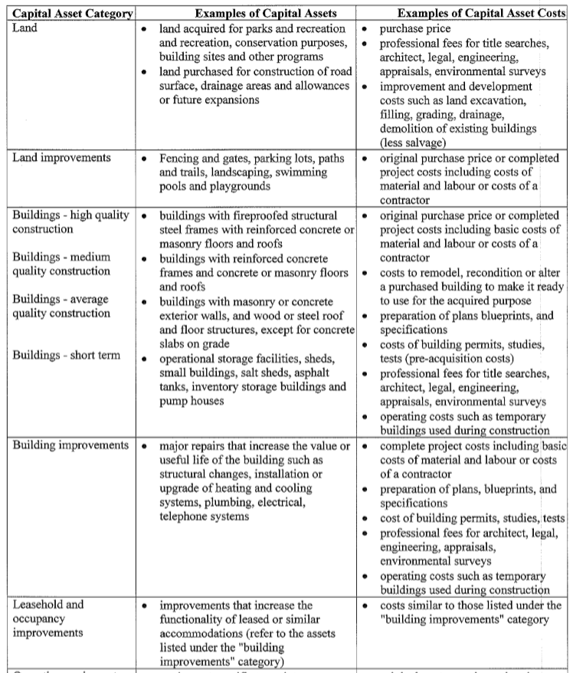
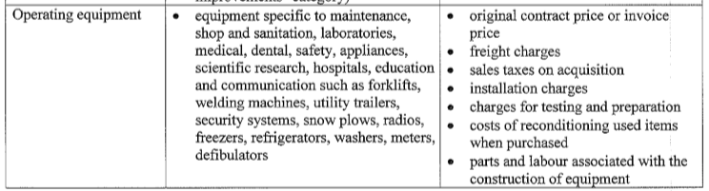
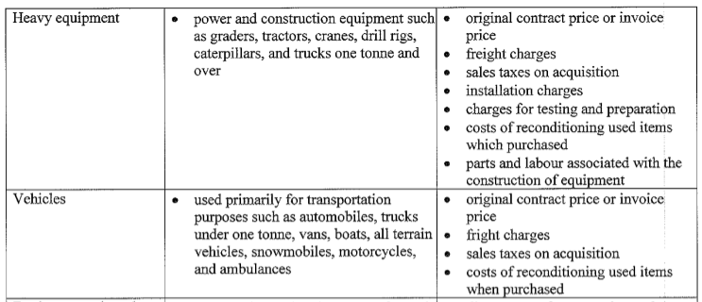
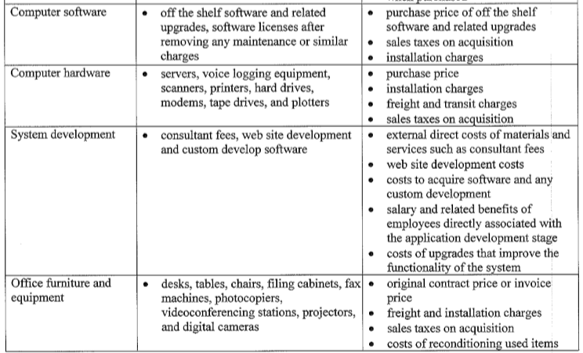
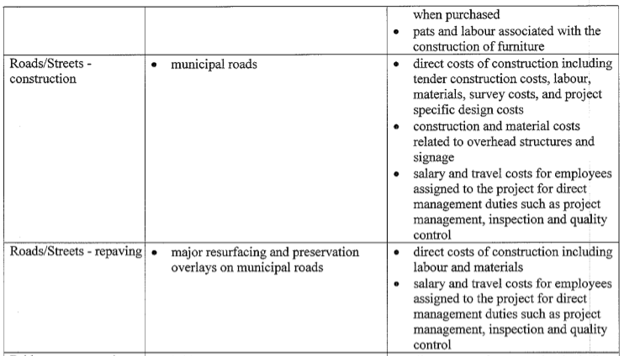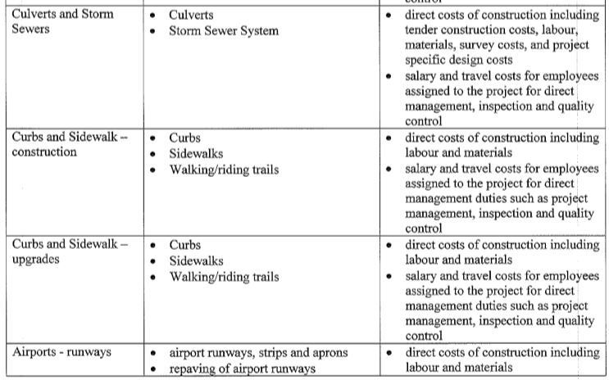

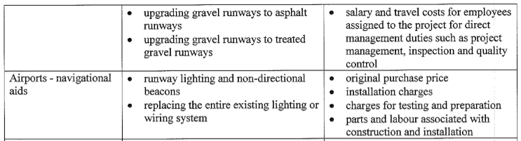
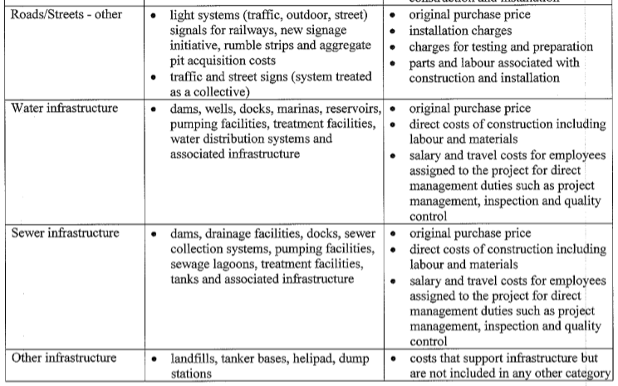

Schedule B

6.0 CAPITAL ASSET THRESHOLDS, ESTIMATED USEFUL LIVES AND AMORTIZATION

The table felow outlines the threshold and estimated useful life application to each capital asset category. A threshold of ALL would mean that all capital purchaes, regardless of cost, are recorded.

